Sprint Increment Report

**Client/Sponsor: Mr. Akshat Bajaj**

**Academic Supervisor: Dr Thanh Nguyen**

**Project Team**

***Squad 2-C1***

Damini Bevoormandya Jayaramu, 218492045

Dipesh Bhatta, 218439043

Harmilap Singh, 218687321

Md Ibn Sikbatullah, 218444302

Sai Krishna Kesineni, 218465396

Salman Khan, 218187674

***Squad 2-C2***

Unique Poudel, 217492278

Akhil Peddineni Peddineni, 218203977

Bharathi Bai Banavathu, 218146363

Premtej Rajayya, 217346677

Dhruv Bhatt, 218223444

Dear *Akshat Bajaj*,

We look forward to reporting the progress of this sprint. We have captured the following

points to update you on how things are going and if we have encountered any hurdles in

our execution.

This recent sprint focused on *deliverable #1* and the coming sprint will focus on *the progress*

*of that deliverable.*

**Outcome(s) of this Sprint:**

 Two new example projects of Data science will be created on surround AI

framework.

 Data gathering and ETL process will be carried out.

 Blog writing of the process involved in this sprint.

**Activities this Sprint:**

 Learning surround AI framework.

 Gathering data and wrangling it.

 Training data successfully to the model.

 Writing report.

**Activities that will occur next Sprint:**

 Complete, Build and run.

 Explore and implement CircleCi and Sphinx.

 Report writing.

**Proposed amendments to Scope:**

 Code optimization should be done to enhance the performance issue of the projects

on the framework.

Please let us know if you have any questions.

Sincerely,

Team *Surround AI squad 2*



**Deakin University**

**SURROUND-AI**

**Project Scope**

**Project Sponsor**

**Surround Development Team**

**Project Team**

***Squad 2-C1***

Damini Bevoormandya Jayaramu, 218492045

Dipesh Bhatta, 218439043

Harmilap Singh, 218687321

Md Ibn Sikbatullah, 218444302

Sai Krishna Kesineni, 218465396

Salman Khan, 218187674

***Squad 2-C2***

Unique Poudel, 217492278

Akhil Peddineni Peddineni, 218203977

Bharathi Bai Banavathu, 218146363

Premtej Rajayya, 217346677

Dhruv Bhatt, 218223444

Document Version 1.1

**Document Revision History**

|  |  |  |  |  |  |
| --- | --- | --- | --- | --- | --- |
| Date | Version | Editor | Reason | Supervisor Signature | Client Signature |
| 02-04-2019 | 1.0 | Dipesh Bhatt | Creation of Project Scope |  |  |
| 06-04-2019 | 1.1 | Unique Poudel | Additional deliverable and project tasks |  |  |
|  |  |  |  |  |  |
|  |  |  |  |  |  |
|  |  |  |  |  |  |

Table of Contents

Motivation / Problem Description 5

Major Outcomes of the Project 5

Context 5

Value Proposition 6

Core Idea/User Stories/Requirements 6

Target Deliverables 8

1. External Deliverables: 8

2.Internal Deliverables: 8

Roadmap and Execution Strategy 9

Execution Strategy 9

Roadmap 9

Sprint 1 10

Goals 10

Target deliverables 10

Sprint 2 11

Goals 11

Target deliverables 11

Sprint 3 11

Goals 11

Target deliverables 12

Sprint 4 12

Goals 12

Final deliverables 12

Limitations, constraints and considerations 12

# Motivation / Problem Description

The most prominent task of a Data Scientist is to predict the outcomes based on the enormous data. With everything being automated surround AI is designed to help data scientists to automate the process of making reliable predictions with the libraries of surround AI framework.

The project identifies the promising approaches for the evolution of a machine-learning pipeline within the current solution which focuses on end-to-end solution. The extraction of data within the AI products and machine learning algorithm will help data scientists with the deep understanding of the craft of the problem and plan formulation to engineer the solution.

# Major Outcomes of the Project

* Two examples of machine learning project to implement the surround framework. i.e. English Premiere League Score prediction and Apple Shares Price Prediction.
* Write a report based on the implementation of surround on those two examples and describe how it helped.
* Build documents on getting started, examples of using surround and tutorials to use the surround AI framework.
* Logo Design which reflects the Surround
* Help documents, content-creation on Surround, website design, UX/UI requirements
* Reporting of the whole project based on the implementation of surround with its use cases, unique value proposition discussion and its advantages.

# Context

The development of Data Science with hundreds of algorithms and frameworks have made the life of data science easier than in the past. However, framework has not been properly defined for a specific problem with the deep integration of machine learning algorithm and deployment of AI products on the framework. This project aims to develop a suite of machine learning framework and libraries with the help of research engineers to deploy the AI products unto the framework for automated prediction and efficient knowledge extraction from the Data Sets.

Surround is a lightweight framework for serving machine learning pipelines in Python. It is designed to be flexible, easy to use and to assist data scientists by focusing them on the problem at hand rather than writing glue code.

The project has been in the rapid development phase with three major deliverables to be accomplished in four sprints. This document reports the status and sprint goals for the squad2 team.

# Value Proposition

Below mentioned are the few benefits of adopting this solution:

* Commercial: Visual search, visually similar recommendation, chatbots, improve customer satisfaction, inventory and delivery management, competitive advantage, etc.
* Social: Mapping of consumer behavior, chatbots, virtual assistants, etc.
* Technological: Early diagnostics in health care, detect fraud, cut transactional and infrastructural costs, etc.
* Operational: Increase business sales, improve customer experience, automate work processes, provide predictive analysis, inventory and delivery management, competitive advantage, etc.

# Core Idea/User Stories/Requirements

The core idea of the project to develop and enhance the features of surround and undergo three major deliverables. For the efficient operations and effective work productiveness, two squad teams have been divided with four segments of work.

* Create two examples of machine learning project to implement and test the surround AI functionality.
* Create a brand Logo which represents the framework.
* Document the entire framework and examples to suggest further development and explain how surround helped in the machine learning project.

**Team Lead**

Ownership: Unique Poudel

* Reports the sprint updates of English Premier League (Example 1) project and carries out the quality check on the report.
* Handles the team communication channels, meetings with the unit chair, supervisor, clients and stakeholders.
* Reports the progress of the project to the unit chair, supervisor and the client.
* Reports the sprint updates, project scope, increments, Technical report and Ontrack tasks for SIT782.
* Organizes reports, sprint updates from developer and documents of the project.

**Sub- Team Lead**

Ownership: Salman Khan

* Reports the sprint updates of Apple share price prediction (Example 2) project and carries out the quality check on the report.
* Manages Trello Board and assures the tasks are being carried out according to the discussed milestone.
* Assists the squad with Ontrack tasks for SIT764.
* Assists the team with the documentation.

**Documentation**

Ownership:

* English Premeir League Score prediction (Example 1) Md Ibn Sikbatullah, Akhil Peddineni Peddineni, Unique Poudel.
* Apple Shares Price Prediction (Example 2) Damini Bevoormandya Jayaramu, Harmilap Singh, Salman Khan
* Creates the report for Examples with benefits of Surround AI framework and performs the study of framework functionality.
* Creates the blog post regarding the Surround AI framework and how to get started contents.
* Creates one artefact in each sprint to report it to the supervisor and contribute to the workflow of the project.

Performs in-depth study of examples and framework to create a report on:

* Advantages of using surround.
* How did it helped to implement the machine learning project?
* What benefits can data scientists expect from the product?
* What functionalities does surround offer and why is it different than the other legacy framework?
* Suggests further advancement and performs research on problems of Data Scientists.

**Developers**

Ownership: Dipesh Bhatta, Sai Krishna Kesineni

* Creates two machine learning projects of working example in python.
* Each developer is expected to show the artefacts created and implement it in the Surround AI framework to report the functionality of the framework.
* Also, Developers needs to be able to explain both the upsides of using the framework plus the downsides to the documentation team to point-out strong and relevant suggestions.
* Reports the sprint updates, work in progress reports and milestone targets to the team lead.

**Designers**

Ownership: Bharathi Bai Banavathu, Premtej Rajayya, Dhruv Bhatt

* Ideates the logo for the Surround Framework.
* Identifies the requirements of brand color, brand fonts and brand image to represent the Surround framework.
* Demonstrates a design every week to meet the expectations of the client and adds the requirements in each iteration.
* Creates the presentation report for the project to demonstrate the working example and successful deliverable.

# Target Deliverables

The following goals have been identified as dependencies that need to be addressed early in the life cycle of the project.

## External Deliverables:

External deliverables are delivered to the client at the end of the sprint by the corresponding team.

|  |  |  |  |  |  |
| --- | --- | --- | --- | --- | --- |
| S.no. | Deliverable Name | Frequency | Mode of Delivery | Technology used | Ownership |
| 1. | English Premier League Score Prediction  (Example 1) | Each Sprint | GitHub | Python, Surround,  Time series analysis (ARIMA) modelling | Developers |
| 2. | Apple share price prediction (Example 2) | Each sprint | GitHub | Python, Surround | Developers |
| 3. | Documentation | Final Sprint | GitHub | Markdown | Documentation Team |
| 4. | Logo and Presentation | Every Week | Share point/ E-mail | Photoshop, Logo maker | Designers |

## 2.Internal Deliverables:

These deliverables are the minimum requirement of the team members to report the documents to the Team Lead and Supervisor.

|  |  |  |  |  |  |
| --- | --- | --- | --- | --- | --- |
| S. No. | Deliverable Name | Frequency | Mode of Delivery | Ownership | Delivered to: |
| 1. | Logo Design | Each week | Slack, e-mail, share point | Designers | Team lead, Supervisor |
| 2. | Documentation | Every sprint | Slack, e-mail, share point | Documentation team | Team Lead |
| 3. | Developers Sprint Updates, Work in progress | Every sprint | Slack, e-mail, Share point | Developers | Team lead |

# Roadmap and Execution Strategy

The roadmap to the execution and delivery of this project is detailed subsequently.

## Execution Strategy

* Upskilling and understanding the Surround AI framework.
* Gathering data related to the example projects.
* Create the example projects in this framework and run the basic ETL (Extraction Transform and Load) part of the project. Writing blog about it parallelly.
* Incrementally,
* Complete Project build it and run successfully to achieve its goal.
* Explore how Cricleci, Sphinx is improvising the framework, implement it in the example projects and write report about it.
* Explore the feature of packages: ‘surround’, ‘templates’, ‘surround.remote’, ‘surround.runner’, ‘surround.runner.web’ and ‘surround.tests’, implement them on our example projects and document about it.
* Compile all the documents and publish on some renowned site.
* Research on the “surround. Tests” package and try to add some more test suites.

## Roadmap

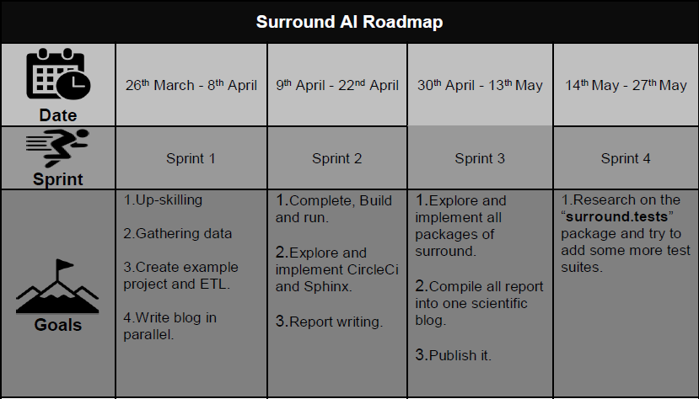

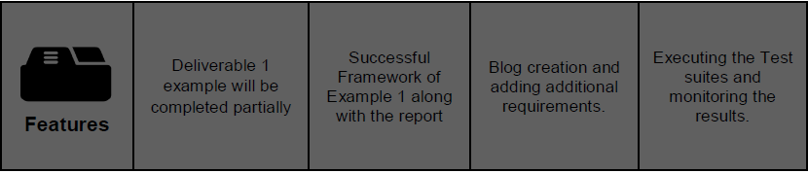

# Sprint 1

## Goals

The goal of Sprint 1 is to deliver scope document and work with (Akshat) to agree on the acceptance criteria and priority for the deliverables. These can be decomposed to:

* Upskilling and understanding the Surround AI Framework
* Gathering the data for the provided examples
* Running the basic ETL functions.
* Initiation of the Blog.
* Installation of python and surround plus other tools to implement.
* Installation of Photoshop and Logo Design maker.

## Target deliverables

Two sets of code in python to implement it in the Surround Framework.

Project Scope, sprint updates and another technical documents creation.

GitHub setup and other project management tools including slack, GitHub, Share point and outlook.

Blog initiation.

Documents and reports on Surround framework and other machine learning projects along with Data analysis and data science research papers.

# Sprint 2

## Goals

The goal of Sprint 2 is to deliver the end to end infrastructure, so we can start collaboratively planning the interfaces to enable integration efforts to commence on (client name)’s side. These can be decomposed to:

* Explore how Cricleci, Sphinx is assisting the framework, implement it in the example projects and write report about it.
* Implement the EPL (English Premiere League) example in the surround.
* Implement Apple share price prediction code example in surround.
* Design a Logo.
* Create reports and documents related to surround.

## Target deliverables

* A docker container encapsulating the transformation engine.
* An invocation script that accepts the input folder, output folder and invocation parameters.
* A deployment document that describes how to install and use the solution.
* Logo Design.
* Documentation on sprint 2 updates of both the examples.
* Research papers and contents related to Surround and Machine learning project plus Data science.

# Sprint 3

## Goals

The goal of sprint 3 are as follows

* Explore the feature of packages: ‘surround’, ‘templates’, ‘surround.remote’, ‘surround.runner’, ‘surround.runner.web’ and ‘surround.tests’, implement them on our example projects and document about it.
* Further improvements on the Logo Design.
* Add more contents and create quality contents for the Getting started documents, tutorials for surround and its technical review documents.
* Compile all the documents and publish on some renowned site.

## Target deliverables

Two data science example projects build on Surround AI framework.

Complete blog describing all the features of Surround AI and how it helps in the creation of organized data science project.

Iteration of Logo design each week.

# Sprint 4

## Goals

The goal of Sprint 4 is described below.

* Create a well-documented report on Surround functionality and the example.
* Explain the functionality of the surround with rich contents and technical description.
* Document the getting started contents, tutorials, help page and other guides to use surround.
* Final logo design which represents the surround.

## Final deliverables

* Logo Design
* Well-documented report on both the examples and Surround.
* Presentation to demonstrate the final deliverable.
* Blog post describing Machine learning, surround framework and getting started contents.

# Limitations, constraints and considerations

The limitations, constraints and considerations of the project are as follows:

* The project may be confined to the first deliverable since fourth deliverable need a good research and apt hand in program testing.
* Lack of experience and specialized resources on the related tasks may lead to incomplete deliverable.
* Programmer and Blog writer miscommunication may lead to wrong report writing.
* Surround AI is still in development phase so due to the time it is officially live, our report may be incomplete in accordance with that.
* Frequent communication with client is needed to acquire the clear vision of the framework.
* Framework should be up to date with the recent git changes to avoid any lagging behind in the deliverable completion.